Git Hub Link

https://github.com/sapnagambhir/IoT-Sensor-Data-Anakyser-using-Machine-Learning.git

**IoT Sensor Data Analyzer**

**Description**

Based on dataset having Temperature, Humidity, Wind and Rain machine learning Model is trained and deployed which will be used to predict binary classification of Rain attribute based on other three parameters.

**Steps Followed**

1. Create account on Cloud.ibm.com
2. IBM Watson Studio (Machine Learning Model)
   * Watson Studio Service is created
3. Dataset
4. IBM IoT platform
   * IBM Platform Service is created
5. IBM IOT sensor Simulator (http://watson-iot-sensor-simulator.mybluemix.net/)
6. Nodered for visualization of Data

Nodered Service and App both are created

**Screen shots**

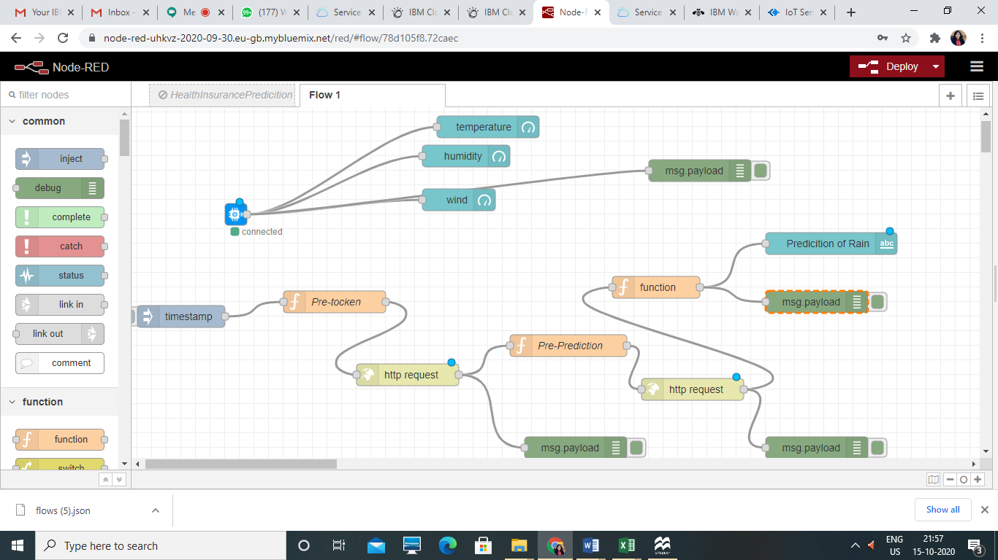

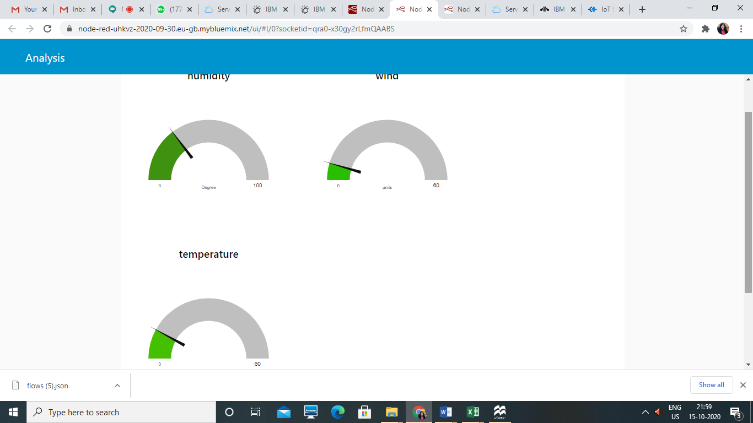

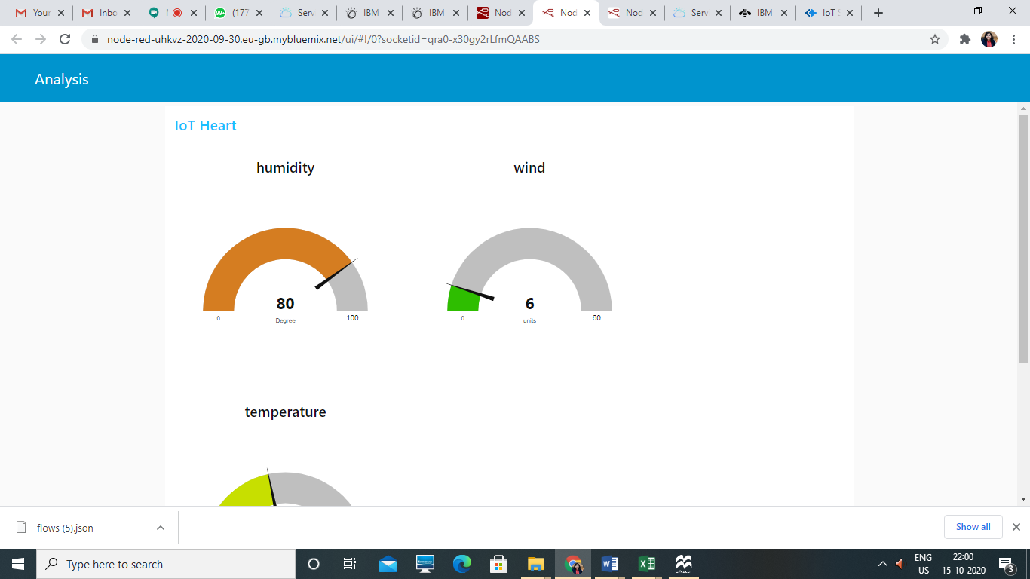

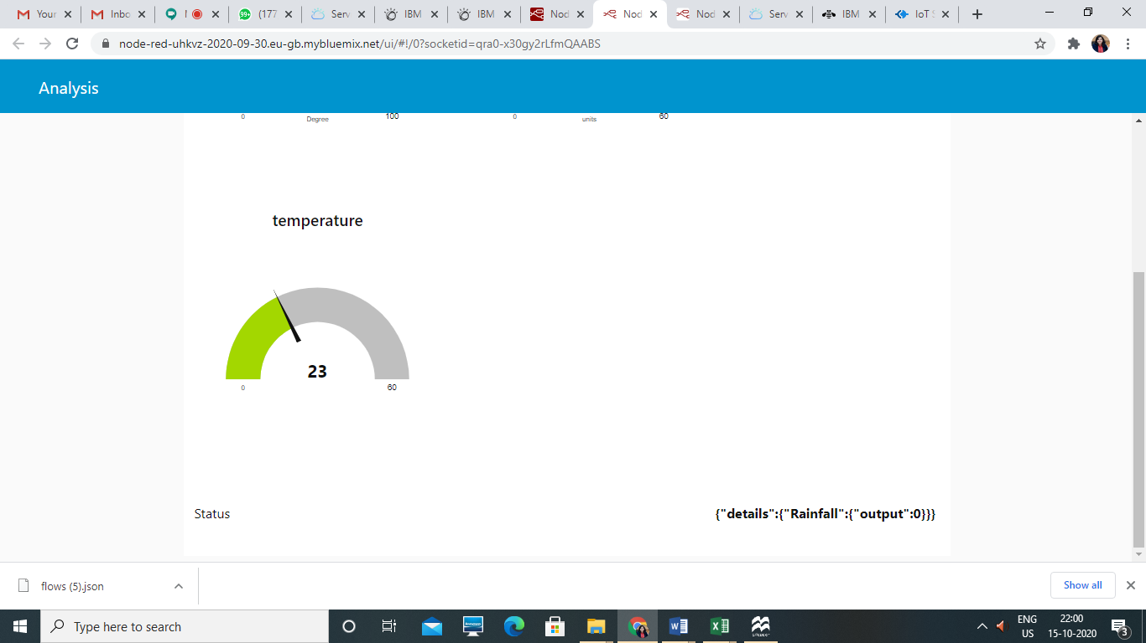

**Details of Various Credentials used during Project Develoopment**

* + Organization ID vc1ixt
  + Bottom of Form
  + Top of Form
  + Device Type Nodemcu
  + Bottom of Form
  + Top of Form
  + Device ID1234
  + Bottom of Form
  + Top of Form
  + Authentication Method use-token-auth
  + Bottom of Form
  + Top of Form
  + Authentication Token CXLujuLU@Cntfwj8n2
  + API key a-vc1ixt-xcsr6thu4j
  + Authentication token Pj&9XlcSTsHYhQRw41
  + <https://us-south.ml.cloud.ibm.com/ml/v4/deployments/49936ba5-a84e-4de0-97b1-3e267147f3dd/predictions>
  + IOt data analyser api key (ML)
  + B8jcF2q-3L-5Tsgqi_Cs8OIC1g4HLm1pfB76E40M7vDu